1. The main reason why we say Node uses an Event-Driven architecture is because when an event triggers, Node hooks a callback to this particular event. The event loop listens for event triggers and invokes the dedicated event handler for that event.
2. It’s possible but node will be slower in terms of performance since it the v8 has only one thread.
3. The rendered process figures out the structure of a document and styles for each node. However, this is not enough to render a page. The geometry of elements should be known. The lay-out tree stores information related to geometry of elements and what’s visible on the page.

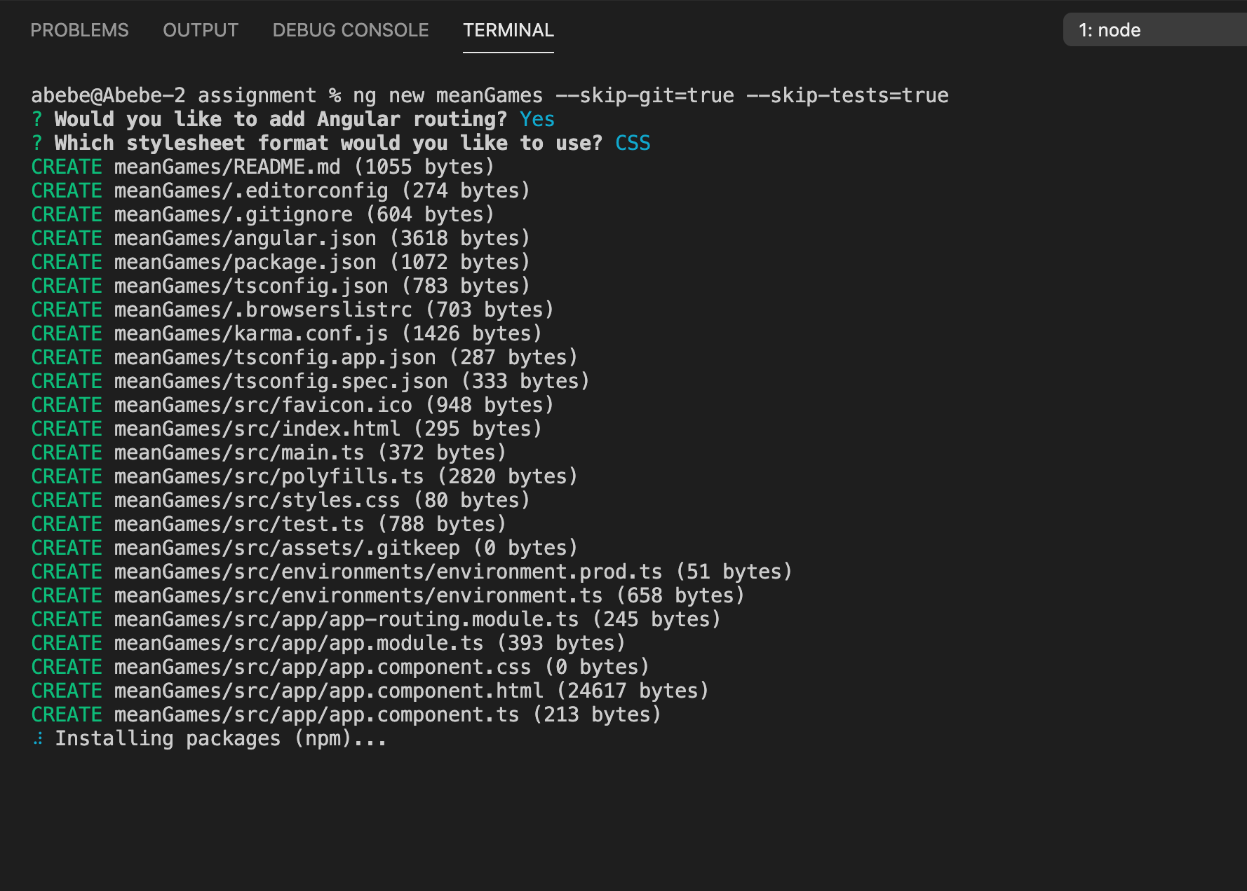

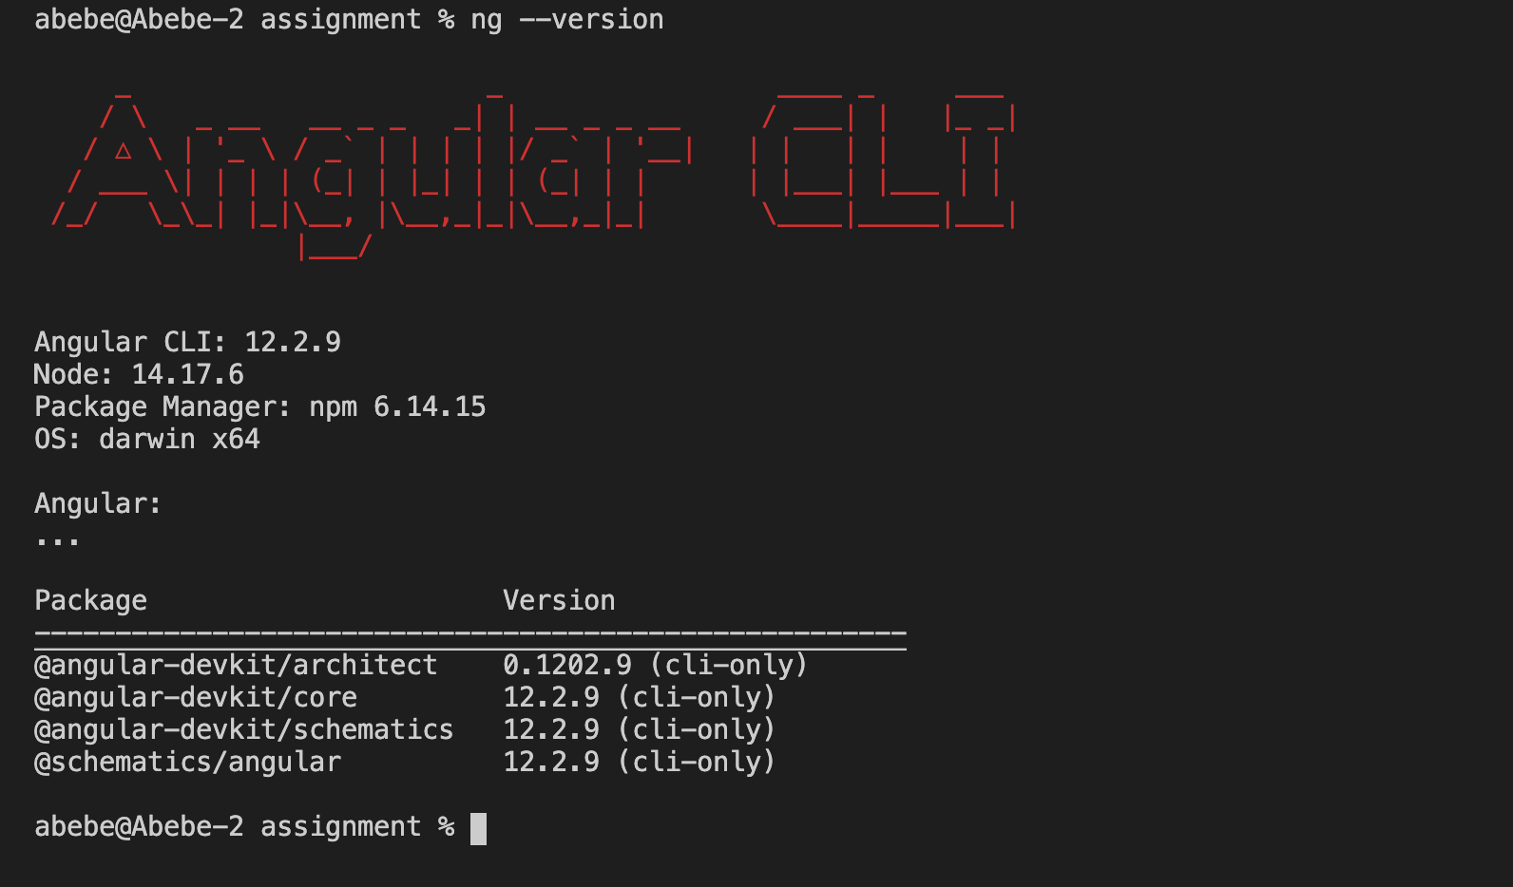

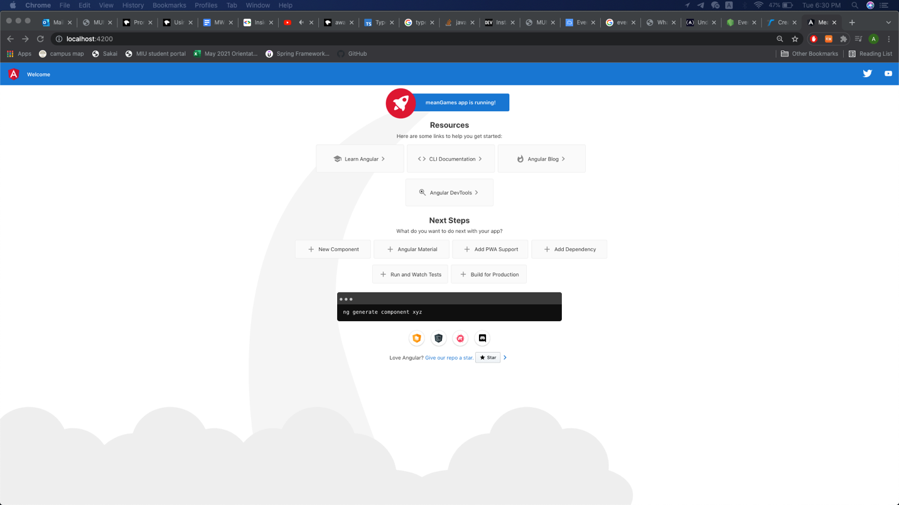

1. <https://github.com/AbebeT/Modern-Web-Applications---Labs/tree/main/Week3%20Day2/http>

